21BDS0340

Abhinav Dinesh Srivatsa

Java

Packages Practise

Package/File Hierarchy

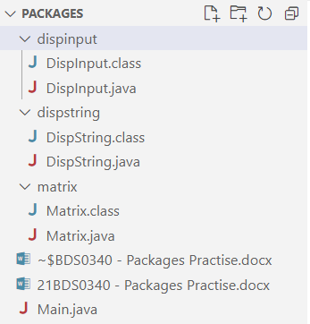

DispInput.java Code

package dispinput;

import java.util.Scanner;

public class DispInput {

  public void displayInput(Scanner s) {

    System.out.print("Enter string: ");

    String str = s.next();

    System.out.println(str);

  }

}

DispString.java Code

package dispstring;

public class DispString {

  public void displayString() {

    System.out.println("Hello VIT");

  }

}

Matrix.java Code

package matrix;

import java.util.Scanner;

public class Matrix {

  public int[][] getMatrix(Scanner s, int size) {

    int matrix[][] = new int[size][size];

    for (int x = 0; x < size; x++) {

      for (int y = 0; y < size; y++) {

        System.out.print("Enter row " + x + " col " + y + ": ");

        matrix[x][y] = s.nextInt();

      }

    }

    return matrix;

  }

  public int[][] addMatrices(int mat1[][], int mat2[][], int size) {

    int out[][] = new int[size][size];

    for (int x = 0; x < size; x++) {

      for (int y = 0; y < size; y++) {

        out[x][y] = mat1[x][y] + mat2[x][y];

      }

    }

    return out;

  }

  public int[][] multiplyMatrices(int mat1[][], int mat2[][], int size) {

    int out[][] = new int[size][size];

    for (int x = 0; x < size; x++) {

      for (int y = 0; y < size; y++) {

        for (int z = 0; z < size; z++) {

          out[x][y] += mat1[x][z] \* mat2[z][y];

        }

      }

    }

    return out;

  }

  public void displayMatrix(int mat[][], int size) {

    for (int x = 0; x < size; x++) {

      for (int y = 0; y < size; y++) {

        System.out.print(mat[x][y] + " ");

      }

      System.out.println("");

    }

  }

  public void doStuff(Scanner s) {

    System.out.println("Enter size: ");

    int size = s.nextInt();

    System.out.println("Matrix 1: ");

    int matrix1[][] = getMatrix(s, size);

    System.out.println("Matrix 2: ");

    int matrix2[][] = getMatrix(s, size);

    System.out.println("");

    int sum[][] = addMatrices(matrix1, matrix2, size);

    int prod[][] = multiplyMatrices(matrix1, matrix2, size);

    System.out.println("Sum: ");

    displayMatrix(sum, size);

    System.out.println("Product: ");

    displayMatrix(prod, size);

  }

}

Commands

Main.java Code

import dispinput.DispInput;

import dispstring.DispString;

import java.util.Scanner;

import matrix.Matrix;

public class Main {

  public static void main(String[] args) {

    Scanner s = new Scanner(System.in);

    (new DispString()).displayString();

    (new DispInput()).displayInput(s);

    (new Matrix()).doStuff(s);

    s.close();

  }

}

Output Screenshot

